Assessment task 2

Ciarán Maher 25th-April-2016

KTQ0855

Design document for Payroll Manager 9001®

Requirements
Requirements Catalogue Entry
System: Payroll Manager 9001 | Date: 27th/06/2016
Author: Ciarán Maher | Page:1

Functional Requirement
Req No:1.0
Description:
Create a program with a simple command-line, menu system that allows a user to create, read, update and delete employee details
Allow the user to calculate the payroll for all registered employees
Save output to a file with today’s date in the file name

Non-Functional Requirements
Program should be as intuitive as is possible with a command line based program
Program should include standardised menu system to make user experience as painless as possible.

Related Documents
Data flow diagram

Suggested Solution(s)
Google Sheets Document
Visual Basic in-house solution
C programmed text based accounts package

Actual Solution
C programmed text based accounts package

Data flow diagram

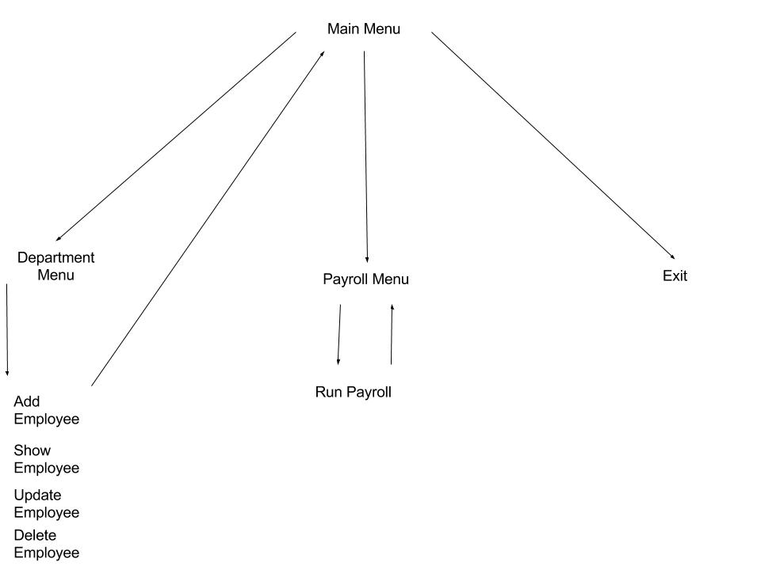 Pseudocode for necessary methods
mainMenu
This method draws the main menu for the user to interact with. Also controls user input for main menu system.
employeeMenu
This method draws the employee menu for the user to interact with. Also controls user inputs for employee menu system.
payRollMenu
This method draws the payroll menu for the user to interact with. Also controls user inputs for payroll menu system.

add_new_employee
Creates a new Employee record of typedef struct
{
double Id, payRate, hours, gross;
char firstName[50];
char secondName[50];
char department[5];
}
print_all_details
This method iterates all Employee records and prints the details to the screen.
update_employee
The update_employee method allows the user to select an existing Employee record by id number, and then change any of the inputted details.
delete_employee
This method allows the user to delete an existing Employee record by id number.
run_payrRoll
This method begins the payroll creation process. First creating the file, then outputting the contents of the Employee record to the file.

Objects, data and file structures

Employee Record
Each Employee record stores all required data, this includes:
First name: | Char Array [50]
Second name : | Char Array [50]
Department: | Char Array [5] IT/TEST/HR/SALES
Pay rate: | Double
Hours: | Double
Gross: | Double

